

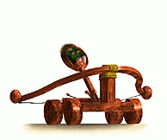The purpose of this lab is hit a designated target using the concepts of physics and projectile motion. When projectile motion is taught in introductory physical science courses, air resistance is never really considered, even though we know that it can have a big effect on the motion of a projectile. After all, air resistance is what prevents skydivers that are jumping out of airplanes from hitting the ground below at fatally high speeds. The reason air resistance is often ignored is not because it is unimportant in the real world, but rather because of the large number of calculations necessary to compute an accurate trajectory when air resistance is included. We will conduct trials that will take this air resistance into account.

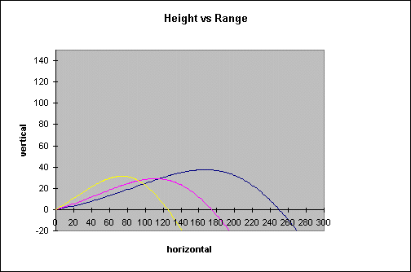
If we ignore air resistance (or assume air resistance is negligible) so that gravity is the only force acting on the projectile, the equations of its motion are very easy to solve. For example, the equation for the range (horizontal distance) a projectile travels is simply:

R = v_{o}* cos (x) * t

where v₀ is the launch speed, x is the launch angle, g is the gravity constant, and t is the time the object is in the air. Keep in mind, it is not critical you memorize this equation, just notice how simple it is to use. However, our simple assumption that gravity is the only force acting on the projectile is incorrect, at least in the real world. On earth, air resistance plays a significant role in the distance a projectile will travel. And to make matters worse, in general air resistance depends on the speed of the object, so the air resistance will decrease if the speed decreases and will increase if the speed increases. The trajectories shown are characteristic of the trajectory of an object that is experiencing wind resistance. Notice that the objects slow down and drop more rapidly in the diagram above.

For this first part of this lab you will be able to conduct 8 trials with the catapult. You may alter any of the variables that you prefer; however, I would like to remind you that if you change more than one variable at a time you will not know which change effected the results more or to what extent. The data that you collect from these trials will then be used by you to make calculations or estimations for adjusting the catapult to hit a specified target at an unknown distance. Strategy is very important in this phase. You will be able to measure velocity, angle of release, distance, and time.

The second part of the lab will be to hit a specific target at a distance that will be given to you just prior to launch time. You will be given 3 attempts. The team that hits the target the most or with the least attempts will win. The catapult will not be allowed to move. Ties will be broken with a one shot attempt at a new distance.

Data Collection Table

Trial 1
Trial 2
Trial 3
Trial 4
Trial 5
Trial 6
Trial 7
Trial 8

Calculations

- How do Newton’s 1st, 2nd, and 3rd Law’s apply to this experiment?
Newton’s 1st Law
__________________________________________________________________________________________________________________________________________________________________________________________________________________________________________________________________________________________________
Newton’s 2nd Law
__________________________________________________________________________________________________________________________________________________________________________________________________________________________________________________________________________________________________
Newton’s 3rd Law
__________________________________________________________________________________________________________________________________________________________________________________________________________________________________________________________________________________________________
- How do your calculated distances and actual distances compare for this lab and why?
__________________________________________________________________________________________________________________________________________________________________________________________________________________________________________________________________________________________________
__________________________________________________________________________________________________________________________________________________________________________________________________________________________________________________________________________________________________

